## **Safety Card of Heroin Anonymous**

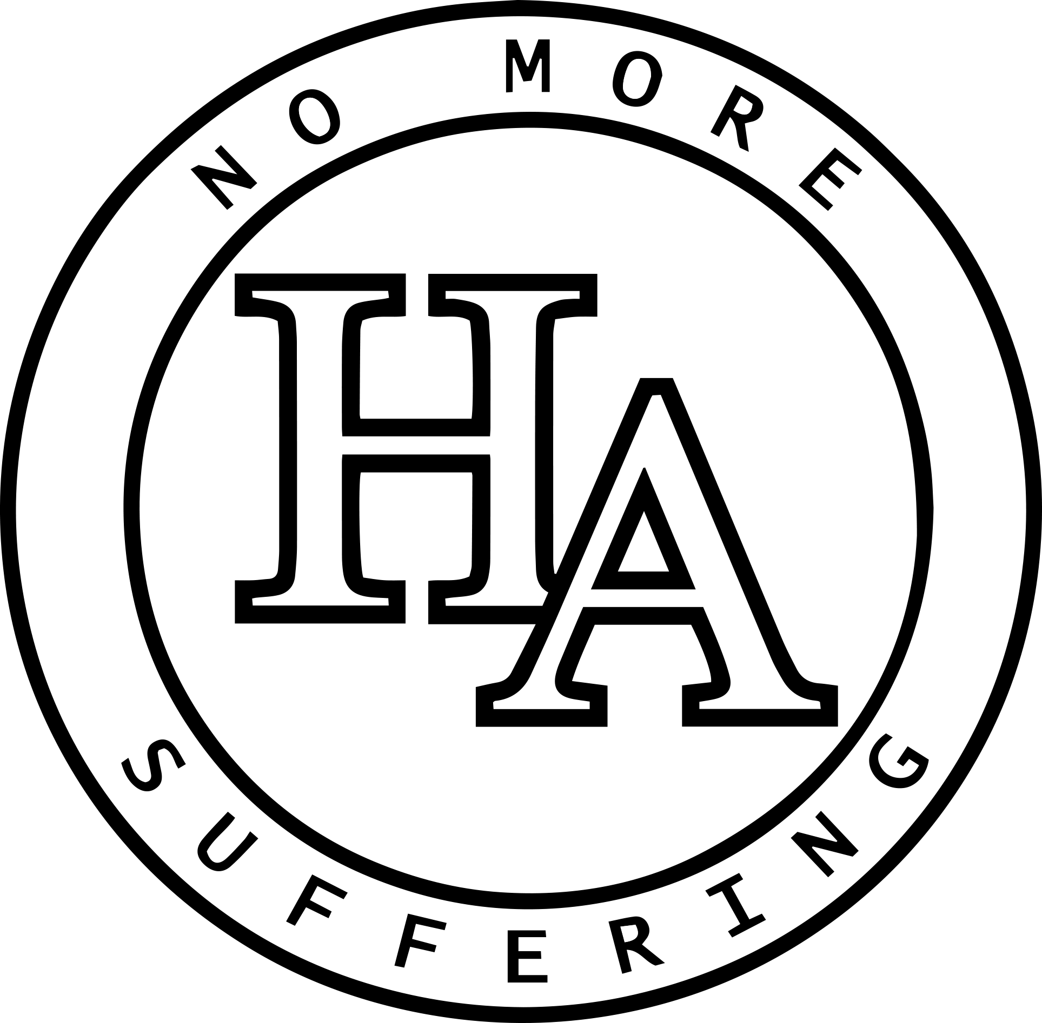

**Heroin Anonymous’s First Tradition:**  
“Our common welfare should come first; personal recovery depends on H.A. unity.”

As active heroin addicts, many of us placed ourselves in compromising and dangerous situations. Most of our experiences demonstrate that while we are focused on survival, little internal growth can be achieved. As recovered members of Heroin Anonymous (H.A.), our experience shows that a safe environment is ideal for a psychic change to take effect. We have found that a spiritual awakening is necessary to foster recovery and nurture unity. Therefore, H.A. seeks to provide safe and welcoming meeting spaces for all who find our groups. To ensure that all who attend our meetings contribute to creating a safe environment, we ask that attendees avoid any and all conduct that endangers or jeopardizes other people.

The foundation of our Traditions is anonymity; however, this principle does not seek to provide protection for illegal or predatory behavior. In this fellowship, we strive to stand on spiritual principles and not hide behind them. Behaviors such as violence, bullying, stalking, harassment, and unwanted sexual advances are in direct conflict with our message of recovery. In turn, each group gets to decide how its members cultivate a safe environment in their meeting. It should be noted that addressing such behavior or contacting law enforcement when needed does not go against our Traditions.

**If you are currently feeling unsafe, we encourage you to approach the chairperson or a homegroup member**